**COFFEE SALES**

**Problem Statement**

* The coffee shop is struggling to understand its sales performance. The specific areas of concern include:
* Total sales analysis
* Total order analysis
* Total quantity sold analysis
* Sales analysis by weekdays and weekends
* Sales analysis by store location
* Daily sales with average line
* Sales analysis by product category
* Top 10 products by sales
* Sales analysis by days and hours
* The goal is to analyze these aspects to identify key drivers of sales and areas for improvement.

**Tools Used**

* MySQL: For storing and querying sales data.
* Excel: For initial data cleaning and preparation.
* Power BI: For data visualization and exploratory data analysis

**ANALYSIS OF PIZZA SALES USING SQL**

1. Total Sales

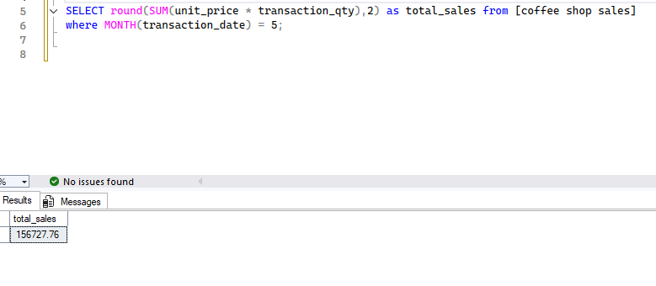

1. Total Orders

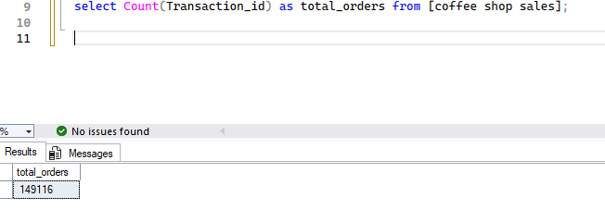

1. Total Quantity sold

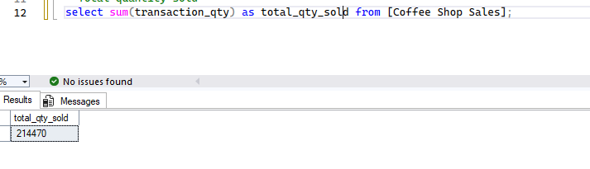

1. Calendar Table—Daily sales, Quantity and total Orders

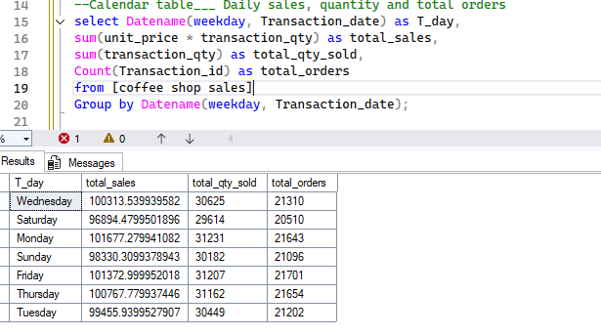

1. Monthly Trend for total sales

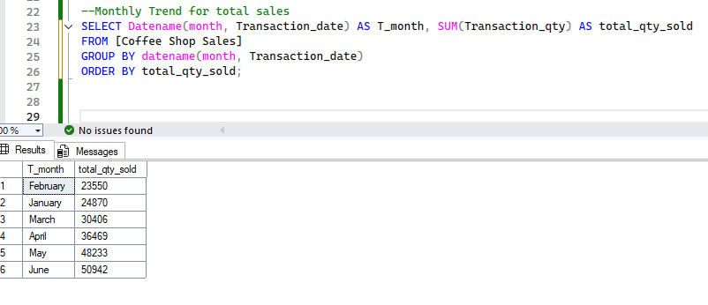

1. Sales over Period

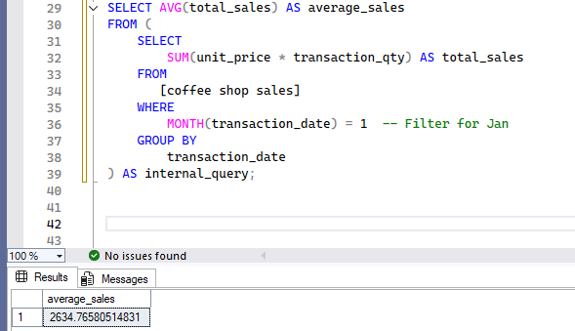

1. Daily sales for selected month

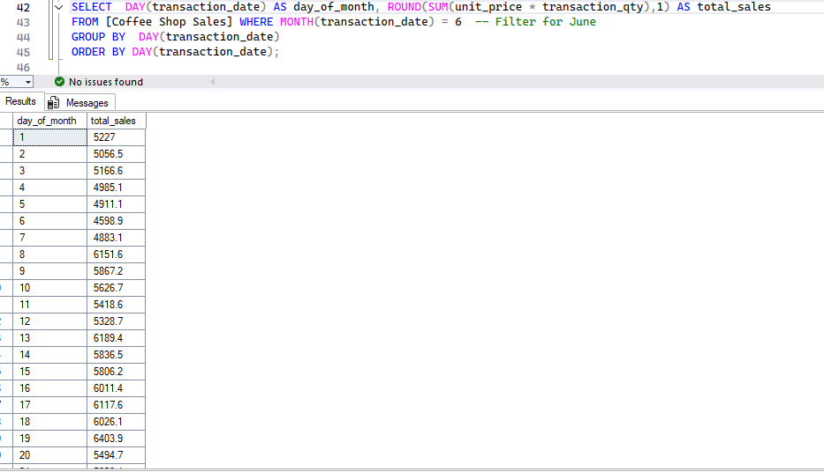

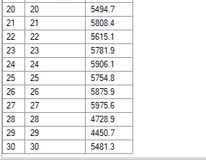

1. Sales by weekend/Weekdays

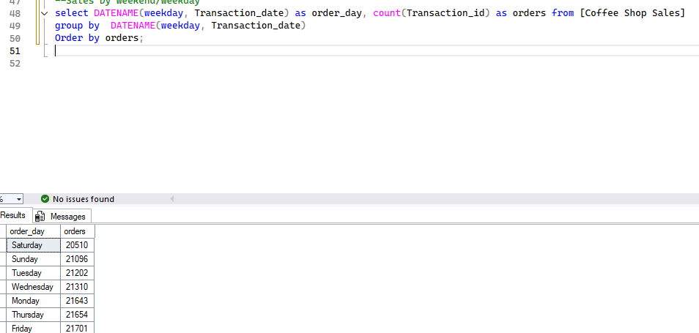

1. Sales by store location

select store_location, Round (Sum(Transaction_qty*unit_price),2) as total_sales from [Coffee Shop Sales]

Group by store_location;

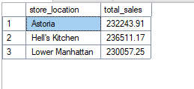

1. Sales By product Category

select product_category, Round(Sum(Transaction_qty*unit_price),2) as total_sales from [Coffee Shop Sales]

Group by product_category;

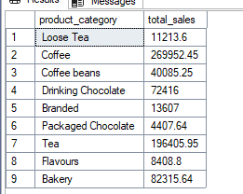

1. Sales by top 10 product type

select TOP 10 product_type, Round(Sum(Transaction_qty*unit_price),2) as total_sales from [Coffee Shop Sales]

Group by product_type;

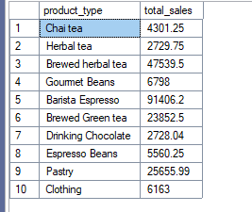

1. Hourly trend

select DATEPART(hour, Transaction_time) as hour_of_day, sum(transaction_qty) as Total_qty_sold from [Coffee Shop Sales]

group by DATEPART(hour, transaction_time)

order by DATEPART(hour, transaction_time) asc;

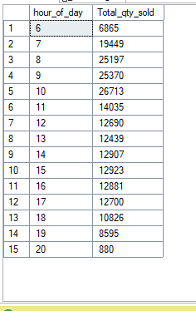

Power BI Dashboards

**Build Dashboard or a Report using Power BI**

